
Renewed Surface Water Management Program FAQs

What is Surface Water Management?
Surface Water Management incorporates traditional earthen drainage networks and Drainage Course Declarations (DCD)s and enhancement of catchment environmental features. An earthen drain, either GMW Primary Drain or Community Drain, is described as a Surface Water Management System (SWMS) which are built to provide more efficient and effective drainage of excess surface water resulting from either irrigation or rainfall. SWMS’s are designed to typical remove run-off from irrigated land resulting from a 50mm in 24 hour (50% AEP) rainfall event and convey it to a natural stream. Improved whole of catchment surface water management:
- prevents excessive waterlogging on productive agricultural land;
- reduces the amount of water contributing to shallow watertables rising (which also reduces salinisation risks); and
- protects the environment and civil assets including roads from damage caused by high watertables and surface water ponding.
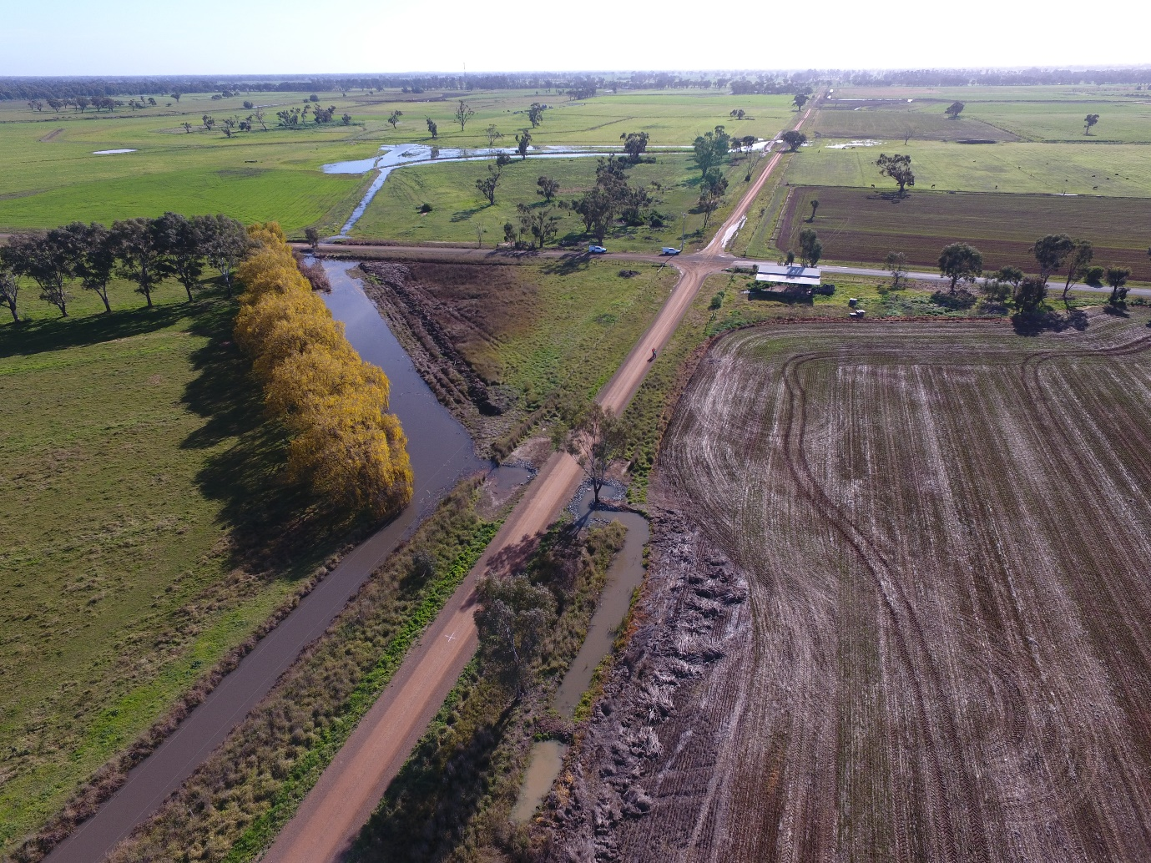

What is a Primary Surface Water Management System?
Primary SWMSs are generally earthen, open-cut and fenced systems owned and maintained by GMW. Primary SWMSs completed under the Surface Water Management Strategy are designed to remove, in 5 days, a 50mm summer rainfall event in 24 hours (1 in 2 year event). Primary SWMSs provide an outfall for smaller Community SWMSs.
What is a Community Surface Water Management System?
Community SWMSs are generally owned and maintained by community groups and are constructed under a cost-share between community groups and Government. Community SWMSs are smaller than Primary SWMSs as they service smaller catchments. Community SWMSs are designed to remove, in 5 days, the runoff from a 50mm 24 hour summer rainfall event (1 in 2 year event). Ownership of a number of Community SWMSs has been transferred to GMW who became responsible for operation and maintenance. Drainage rates are collected to cover these costs.
What is a Drainage Course Declaration or DCD?
Drainage Course Declarations recognise natural drainage lines as drainage courses and enable a coordinated program of works to ensure these flow paths are cleared of man-made obstructions. These works allow drainage flow to pass more efficiently under the management of an appointed authority (GMW). DCDs aim to restore the hydraulic characteristics of the drainage line. DCDs may be made over natural depressions, intermittent waterways or permanent waterways to restore flow.
On its own, a DCD will only provide minimal drainage improvement at low flows, even with the removal of obstructions. The main benefit is continuous movement of higher surface flows.
What is the difference between a DCD and a waterway?
A waterway, as defined in the Water Act 1989 is a natural river, creek, stream or water course in which water regularly flows. This includes lakes, lagoons, swamps, marshes and any altered features associated with existing natural channels or wetlands.
There are no conditions or powers for waterways to have maintained or controlled flow of water. Waterways can be declared as DCDs where appropriate in order to give Water Corporations the power to remove flow obstructions and maintain flows through any other maintenance or works required.
What is a Hybrid Surface Water Management System?
A recent review of the existing SIR Drainage Program Strategy showed that the construction of traditional primary and community SWMSs is no longer economically viable.
The review suggested implementing a new type of ‘Hybrid Surface Water Management System’ to connect the remaining undrained areas of the SIR to the existing primary and community SWMS network. Hybrids SMWSs will be adapted to sub-catchments to take advantage of natural drainage lines. Hybrid SWMSs will use drainage course declarations (DCDs) and minor engineering works to remove man-made obstacles to the flow of surface water along natural depressions. Where necessary, constructed community type SWMS may connect natural flow paths to enable movement of water off the landscape.
How quickly will Hybrid Surface Water Management Systems drain water from the landscape?
Hybrid SWMSs will provide a lower level of service than conventional primary and community SWMSs. They will improve the rate of drainage from the landscape, however the rate of flow and level of service for landholders is limited by catchment-specific factors. These factors may include limitations on the gradient of the SWMS, the possible need to pump from low lying areas, and restrictions on the outfall capacity to a constructed SWMS or DCD.
Why is there renewed Government interest in Surface Water Management?
Government funding for drainage in Victoria reduced through the Millennium drought as watertables across the Shepparton Irrigation Region (SIR) dropped by an average of 3m to 2009 due to changing rainfall patterns. Three key drivers this year led to the Victorian Government announcing $15 million for irrigation drainage over the next four years in the 2016/17 budget:
- Ongoing community demand for drainage services in undrained irrigation landscapes.
- The review of the SIR Drainage Strategy in 2015 identified that 103,373 hectares of irrigated land in the SIR still require improved drainage, particularly to manage rainfall-driven waterlogging.
- Following the return to more average climatic conditions post 2010-2011, watertables across the SIR rebounded by around 2m on average across the SIR. The falls in watertable levels caused by a decade of drought was effectively replaced in two wet years, demonstrating the continued risk to productive land, the environment and infrastructure from inadequate drainage and waterlogging.
How is this program different from the previous Surface Water Management Program?
The renewed Surface Water Management Program builds on the significant achievements of the existing Program, which was scaled back in 2009. The new program is based on a review of the previous SIR Drainage Program Strategy and consideration of the changing context of irrigation practices, water availability, climate and economic drivers in the region.
The renewed Surface Water Management Program is centred on providing improved drainage to meet requirements of rainfall events. New hybrid SWMSs will utilise natural drainage lines and enhance their conveyance capacity by implementation of DCD’s.
The new Surface Water Management Program has identified the areas of the SIR which are a high priority for drainage improvements based on physical, economic and environmental criteria, community support for works and the potential for irrigation to continue in the long term.

What will a DCD-based Hybrid Surface Water Management System look like?
DCDs are an integral component of providing lower cost drainage solutions in some parts of the SIR that still require drainage. The establishment of DCDs is the main element of hybrid drainage schemes that are being implemented across the SIR under the current drainage program with all works funded by the Department of Environment, Land, Water and Planning (DELWP). The intent of DCD-based hybrid drainage is to:
- remove rainfall runoff on irrigated land by increasing the effectiveness of natural drainage lines (drainage courses) as an alternative to a traditional constructed drain (e.g. a primary SWMS)
- provide the legal authority to improve flows in natural drainage courses by removing man-made obstructions, and to prevent future obstructions.
What will the impacts on water quality be?
Water quality impacts are an integral part of the environmental assessment required for drainage works. Environmental engineering techniques, particularly utilising nutrient uptake by wetlands, are a key tool in improving the water quality of drainage flows and mitigating the impacts on the environment and third parties. Drainage outfalls to waterways are managed by GMW.
When will I get drainage services for my farm?
The renewed SWMP has delivered two GMW Primary Drain extensions and a community drain in the Muckatah catchment which are outlined in the Priority Construction Projects Fact Sheet.
The Upper Deakin DCD and Cornella Creek DCD have been completed and details are outlined in the Renewed Surface Water Management Program Fact Sheet. The Guilfus Congupna DCD works program is planned to commence in September 2020. The Murray Valley Drain 11 DCD is currently in the planning stage with engagement planned to commence in October 2020.
The on-farm package for drainage management in areas that are not prioritised for new SWMSs will be developed in conjunction with the Whole Farm Planning Program and Hybrid SWMSs.
Who can I speak to about the renewed Surface Water Management Program?
For general information about the program, visit the website: https://www.gbcma.vic.gov.au/sustainable_irrigation/sircs_surface_water_management_program
What agencies are involved in the Program?
Goulburn Broken CMA: The GBCMA is the agency project managing the renewed SWMP.
Goulburn-Murray Water: GMW are responsible for delivering all construction and works for Primary, Community and Hybrid SWMSs under the renewed Program.
Agriculture Victoria: The Agriculture Victoria Irrigation Farm Services Team will carry out all extension and landholder engagement through the renewed SWMP.
Local Government: Local Governments play a crucial role in the SWMP in land managers (e.g. roadsides in the planning processes and as financial contributors to community SWMS.

